Bug #1
Summary
In mobile device mode, there are different blocks and there is a slider
Description
1) Go to google devtools;
2) Select screen resolution of mobile phone.
Actual result
“Position” field has changed its size. A slider has appeared in the list of employees.
Expected result
The layout was adapted for a mobile device, all blocks are same size, there are no sliders.
Reporter
Yaroslav Panimash
Fix versions
None
Severity
Major
Priority
Determined by the project manager
Environment
Windows 10 Home x64, Google Chrome version 87.0.4280.141
Attachment
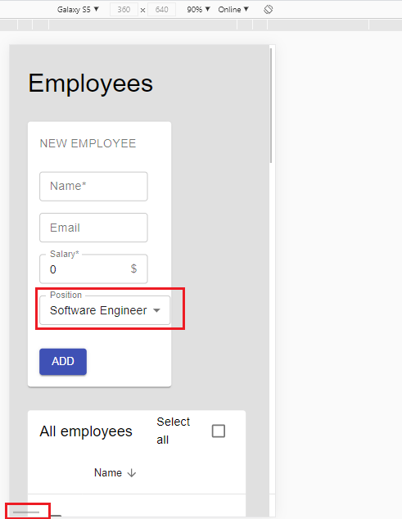
Affects versions
None
Due date
17/Feb/21
Assignee
Project manager

Bug #2
Summary
"Position" list not alphabetical
Description
1) In "Position" field, click on the "Drop-down lists" icon.
Actual result
The list does not open in alphabetical order.
Expected result
A list will open the list should be arranged alphabetically.
Reporter
Yaroslav Panimash
Fix versions
None
Severity
Minor
Priority
Determined by the project manager
Environment
Windows 10 Home x64, Google Chrome version 87.0.4280.141
Attachment

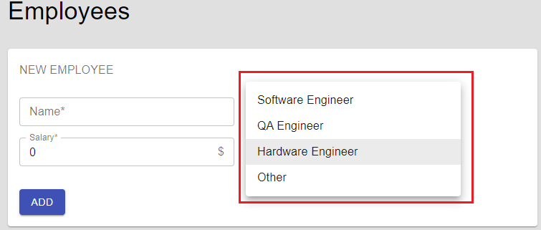
Affects versions
None
Due date
17/Feb/21
Assignee
Project manager

Bug #3
Summary
Entered position is not displayed in records
Description
1) In "Position" field, click "Drop-down lists" icon;
2) Select "Other";
3) Enter valid data in "Position" field that appears.
Actual result
The field name "Other" is displayed instead of the entered position.
Expected result
Data passes without errors and after adding a record, entered data is displayed.
Reporter
Yaroslav Panimash
Fix versions
None
Severity
Blocker
Priority
Determined by the project manager
Environment
Windows 10 Home x64, Google Chrome version 87.0.4280.141
Attachment

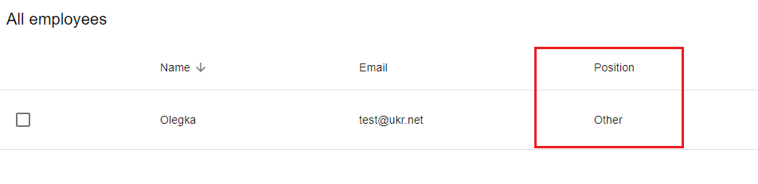
Affects versions
None
Due date
17/Feb/21
Assignee
Project manager

Bug #4
Summary
The "Name" field cannot be edited on "EDIT EMPLOYEE" page
Description
1) Go to "EDIT EMPLOYEE" page;
2) Change text in "Name" field;
3) Click "EDIT" button.
Actual result
The text in the "Name" field is not changed.
Expected result
"Name" field should change to entered one.
Reporter
Yaroslav Panimash
Fix versions
None
Severity
Blocker
Priority
Determined by the project manager
Environment
Windows 10 Home x64, Google Chrome version 87.0.4280.141
Attachment

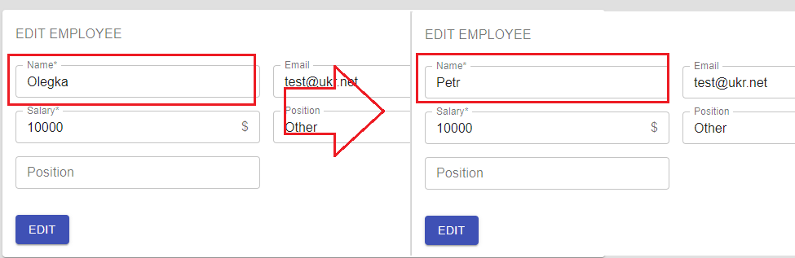
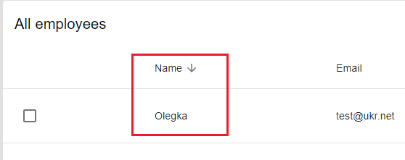
Affects versions
None
Due date
17/Feb/21
Assignee
Project manager
Bug #5
Summary
Number of characters in the "Name" field is not limited.
Description
1) Go to field "Name";
2) Enter more than 50 characters in the field "Name".
Actual result
There is no limit on the maximum number of characters.
Expected result
Limit the maximum number to 50 characters. Field does not accept data and throws an error. "ADD" button is inactive.
Reporter
Yaroslav Panimash
Fix versions
None
Severity
Major
Priority
Determined by the project manager
Environment
Windows 10 Home x64, Google Chrome version 87.0.4280.141
Attachment

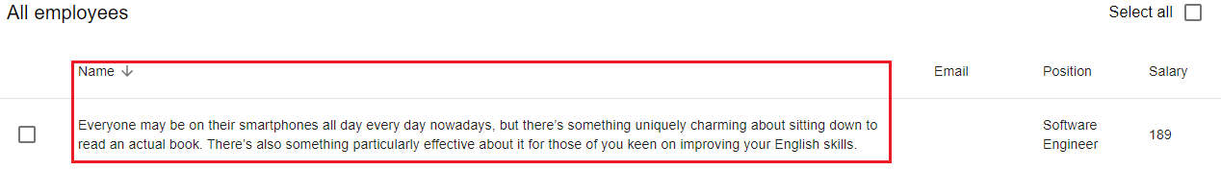
Affects versions
None
Due date
17/Feb/21
Assignee
Project manager

Bug #6
Summary
Number of characters in the "Email" field is not limited(Username length).
Description
1) Go to field "Email";
2) Enter more than 64 characters in the field "Email".
Actual result
There is no limit on the maximum number of characters.
Expected result
Maximum total length of a username is 64 characters. Field does not accept data and throws an error. "ADD" button is inactive.
Reporter
Yaroslav Panimash
Fix versions
None
Severity
Major
Priority
Determined by the project manager
Environment
Windows 10 Home x64, Google Chrome version 87.0.4280.141
Attachment

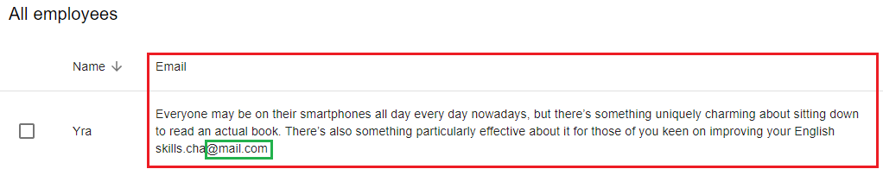
Affects versions
None
Due date
17/Feb/21
Assignee
Project manager

Bug #7
Summary
Number of characters in the "Email" field is not limited(Domain part).
Description
1) Go to field "Email";
2) Enter more than 255 characters in the field "Email".
Actual result
There is no limit on the maximum number of characters.
Expected result
Maximum total length of a username is 255 characters. Field does not accept data and throws an error. "ADD" button is inactive.
Reporter
Yaroslav Panimash
Fix versions
None
Severity
Major
Priority
Determined by the project manager
Environment
Windows 10 Home x64, Google Chrome version 87.0.4280.141
Attachment

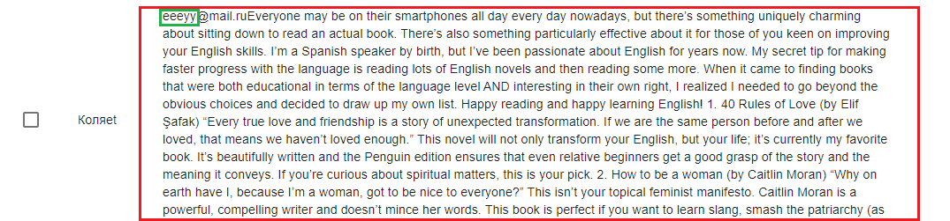
Affects versions
None
Due date
17/Feb/21
Assignee
Project manager

Bug #8
Summary
Number of characters in the "Salary" field is not limited.
Description
1) Go to field "Salary";
2) Enter more than 5 characters in the field "Salary".
Actual result
There is no limit on the maximum number of characters.
Expected result
Limit the maximum number to 5 characters. Field does not accept data and throws an error. "ADD" button is inactive.
Reporter
Yaroslav Panimash
Fix versions
None
Severity
Major
Priority
Determined by the project manager
Environment
Windows 10 Home x64, Google Chrome version 87.0.4280.141
Attachment

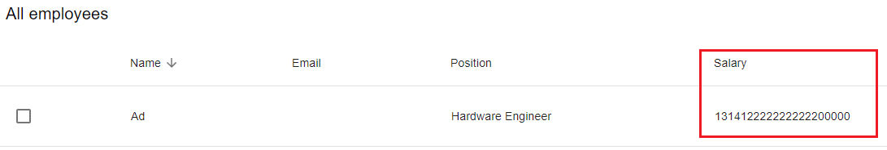

Affects versions
None
Due date
17/Feb/21
Assignee
Project manager

Bug #9
Summary
Minimum number of characters is not specified in the "Name" field.
Description
1) Go to field "Name";
2) Enter 1 character in “Name” field.
Actual result
Field accepts data, "ADD" button is active.
Expected result
Minimum number of characters is 2. Field does not accept data and throws an error. "ADD" button is inactive.
Reporter
Yaroslav Panimash
Fix versions
None
Severity
Major
Priority
Determined by the project manager
Environment
Windows 10 Home x64, Google Chrome version 87.0.4280.141
Attachment

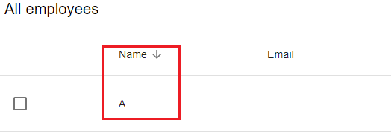

Affects versions
None
Due date
17/Feb/21
Assignee
Project manager

Bug #10
Summary
In the "Name" field can enter characters.
Description
1) Go to field "Name";
2) Enter characters in field.
Actual result
Field accepts data, "ADD" button is active.
Expected result
Field does not accept data and throws an error. "ADD" button is inactive.
Reporter
Yaroslav Panimash
Fix versions
None
Severity
Major
Priority
Determined by the project manager
Environment
Windows 10 Home x64, Google Chrome version 87.0.4280.141
Attachment

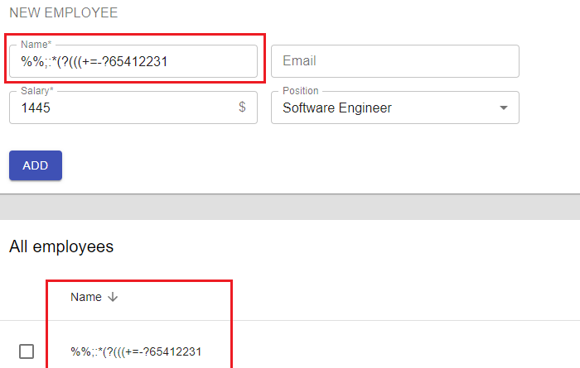

Affects versions
None
Due date
17/Feb/21
Assignee
Project manager
Bug #11
Summary
In the "Name" field can enter numbers.
Description
1) Go to field "Name";
2) Enter numbers in field.
Actual result
Field accepts data, "ADD" button is active.
Expected result
Field does not accept data and throws an error. "ADD" button is inactive.
Reporter
Yaroslav Panimash
Fix versions
None
Severity
Major
Priority
Determined by the project manager
Environment
Windows 10 Home x64, Google Chrome version 87.0.4280.141
Attachment

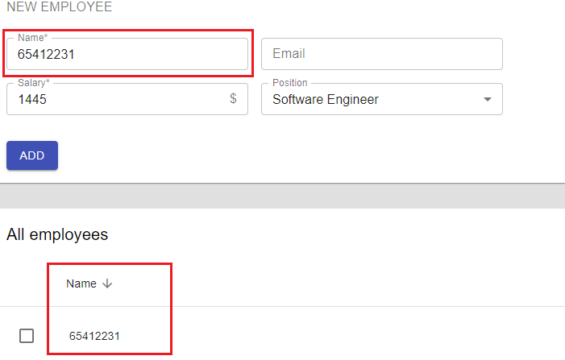

Affects versions
None
Due date
17/Feb/21
Assignee
Project manager
Bug #12
Summary
In the "Email" field can enter characters.
Description
1) Go to field "Email";
2) Enter characters in field.
Actual result
Field accepts data, "ADD" button is active.
Expected result
Field does not accept data and throws an error. "ADD" button is inactive.
Reporter
Yaroslav Panimash
Fix versions
None
Severity
Major
Priority
Determined by the project manager
Environment
Windows 10 Home x64, Google Chrome version 87.0.4280.141
Attachment

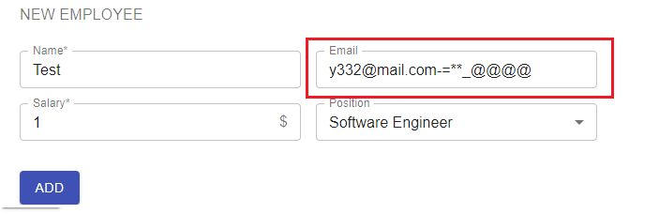

Affects versions
None
Due date
17/Feb/21
Assignee
Project manager

Bug #13
Summary
In the "Email" field can enter numbers.
Description
1) Go to field "Email";
2) Enter numbers in field.
Actual result
Field accepts data, "ADD" button is active.
Expected result
Field does not accept data and throws an error. "ADD" button is inactive.
Reporter
Yaroslav Panimash
Fix versions
None
Severity
Major
Priority
Determined by the project manager
Environment
Windows 10 Home x64, Google Chrome version 87.0.4280.141
Attachment

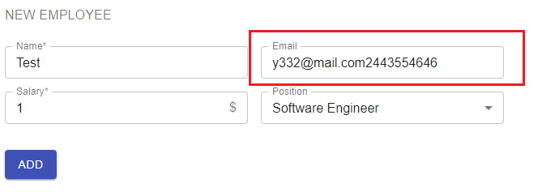

Affects versions
None
Due date
17/Feb/21
Assignee
Project manager

Bug #14
Summary
"Email" field can be filled in Cyrillic on the "CHANGE EMPLOYEE" page.
Description
1) Go to "CHANGE EMPLOYEE" page;
2) Edit data of "E-mail" field, add an inscription in Cyrillic;
3) Press "EDIT" button.
Actual result
Field accepts data and "EDIT" button is active.
Expected result
Field does not accept data and throws an error. "EDIT" button is inactive.
Reporter
Yaroslav Panimash
Fix versions
None
Severity
Major
Priority
Determined by the project manager
Environment
Windows 10 Home x64, Google Chrome version 87.0.4280.141
Attachment

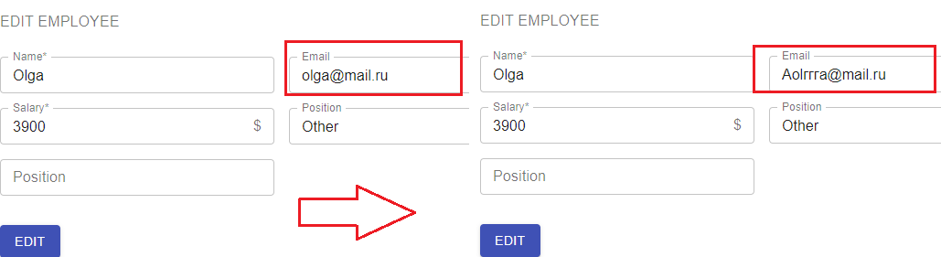

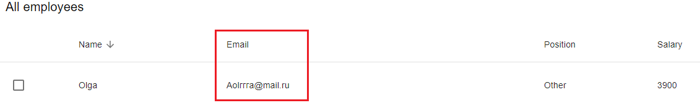

Affects versions
None
Due date
17/Feb/21
Assignee
Project manager

Bug #15
Summary
"Add" button resizes when text changes.
Description
1) Click on the "ADD" button with the right button;
2) "View the element code";
3) Change the name of the button.
Actual result
The button does not contain a limit on the maximum number of characters and can be changed.
Expected result
Button must contain maximum number of characters and must not be resized.
Reporter
Yaroslav Panimash
Fix versions
None
Severity
Major
Priority
Determined by the project manager
Environment
Windows 10 Home x64, Google Chrome version 87.0.4280.141
Attachment

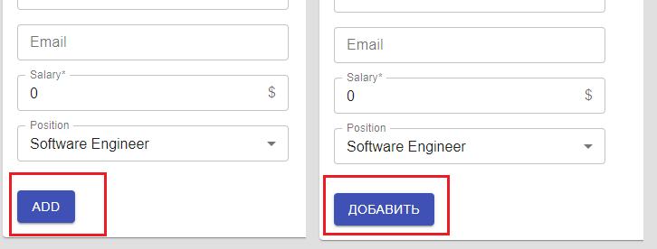

Affects versions
None
Due date
17/Feb/21
Assignee
Project manager

Bug #16
Summary
"Edit" button resizes when text changes.
Description
1) Click on the "EDIT" button with the right button;
2) "View the element code";
3) Change the name of the button.
Actual result
The button does not contain a limit on the maximum number of characters and can be changed.
Expected result
Button must contain maximum number of characters and must not be resized.
Reporter
Yaroslav Panimash
Fix versions
None
Severity
Major
Priority
Determined by the project manager
Environment
Windows 10 Home x64, Google Chrome version 87.0.4280.141
Attachment

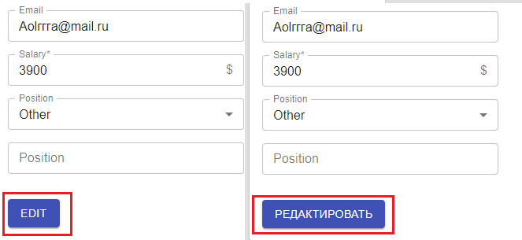

Affects versions
None
Due date
17/Feb/21
Assignee
Project manager

